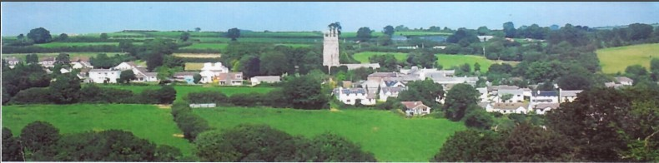
26th June 2023

Dear Councillor,

You are summoned to attend site meetings of North Hill Parish Council on Monday 26th June 2023 2022 at 7pm at Land North Of Moorview Coads Green Launceston Cornwall PL15 7LY Planning Application for New vehicular access to serve offices as well as residential development of 4 houses approved under PA21/10932 and at 7.15pm Side and rear extension with new detached double garage and associated external works at Trezebrah Launceston Road Slipperhill Launceston Cornwall PL15 7QJ. To return to North Hill Village after site meetings.

Please find attached the agenda for our meeting. We ask that if any member of the public has issues, they would like to raise that they contact the clerk prior to the meeting so that we can best manage them.
Please remember that the time allotted for Matters of Community Concern is not a forum to discuss what has taken place during this meeting and that any matter raised here would likely be added to the NEXT meeting agenda for discussion.

Yours faithfully,
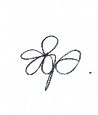
Adele Jones, Clerk to the Council

Members of the public are welcome to attend the meeting. However, we would like those attending to register prior to the meeting by emailing the Parish Clerk. Email: northhillparishcouncil@btinternet.com

AGENDA – EXTORDINARY MEETING
- Planning Applications
  - New vehicular access to serve offices as well as residential development of 4 houses approved under PA21/10932 Land North Of Moorview Coads Green Launceston Cornwall PL15 7LY PA23/03963
  - Proposed sheep shed Kingbeare House North Hill Launceston Cornwall PL15 7NT PA23/03530
  - Listed Building Consent: Reinstatement of lime plaster on the internal walls of the north and south aisles. St Torney’s Church Lynher Way North Hill Launceston Cornwall PL15 7PQ PA23/04512
  - Side and rear extension with new detached double garage and associated external works. Trezebrah Launceston Road Slipperhill Launceston Cornwall PL15 7QJ PA23/04356

- Audit 2022 – 2023
  - Section 1 - Approve the Annual Governance Statement 2022 - 2023
  - Section 2 – Approve the Accounting Statements 2022 - 2023

